A Survey on Cloud Computing and Hybrid Cloud
ABSTRACT
Cloud computing is the recently developing innovation. Every association needs to interface with the cloud computing condition .A survey on distinctive hybrid cloud organization models and cloud benefit models accessible in the field of cloud computing is discussed. An industry pattern has been noted where the utilization of hybrid cloud design can be utilized which supports, the upcoming industry challenges by giving the effective method for putting away their information in the cloud condition by utilizing the mix of both public and private cloud, so that it gives the office to store delicate information on private cloud and less basic information on to public cloud where large storing can be made. Hybrid cloud is particularly profitable for dynamic or extremely adjustable workloads. This paper portrays the overview, service model,traits,supplier storage and issues of cloud computing.
Existing System
All these accessible administrations require an online information exchange. has discussed on these information that might be any private or delicate data like business secret information, MasterCard detail, managing an account exchange and so on, which require more assurance as disclosure of these secret information of any unapproved client may be unsafe. The greatest advancement in the field of computing is capacity and access of information in the cloud, be that as it may, there are numerous things that need to take think about as well. Many creators disclose that cloud computing has a few advantages when contrasted with their drawbacks. Yet, this found that as association of information builds, security of information becomes into a huge issue in spite of the fact that we have to discover a way all you require with a specific administration. Cloud computing has been rising up out of the latest advances in innovation, for example, hardware Virtualization and distributed computing. The refinement with cloud computing is that the processing methodology may continue running on one or many related PCs meanwhile, utilizing the possibility of virtualization
Disadvantages
- Which require more assurance as disclosure of these secret information of any unapproved client may be unsafe.
- this found that as association of information builds, security of information becomes into a huge issue
Proposed System
In this paper, we have discussed about the fundamental components of the cloud computing and the security issues that begin due to the fertilized, shared, public, private and hybrid nature of the cloud. Therefore, the paper proposed various counter measures to address the security issues and various method in the cloud computing
Advantages
- It gives the office to store delicate information on private cloud and less basic information on to public cloud where large storing can be made.
- Hybrid cloud is particularly profitable for dynamic or extremely adjustable workloads.

System Architecture
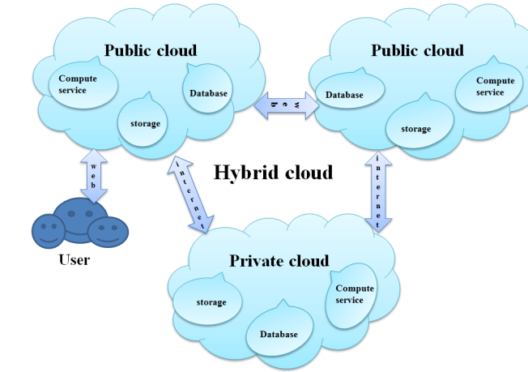
Fig. Hybrid cloud Services Model

Hardware Requirements:

Processor - Pentium –IV
- Speed - 1.1 GHz
- Ram - 256 MB
- Hard Disk - 20 GB
- Key Board - Standard Windows Keyboard
- Mouse - Two or Three Button Mouse
- Monitor - SVGA
Software Requirements:
- Operating System - Windows XP
- Coding Language - java

